
ATAR Biology

Unit 1: Topic 2
Week 8 – Relationships & Interactions

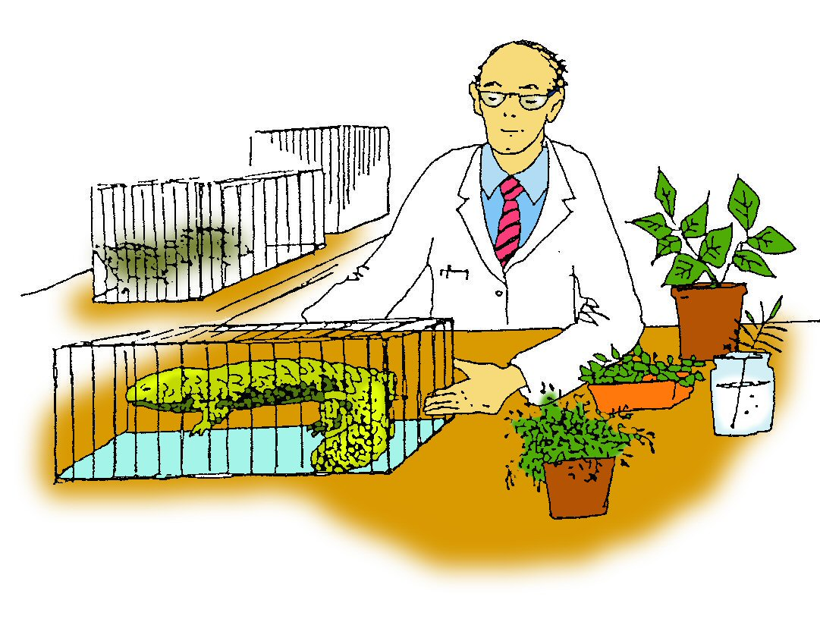

Student Study Notes

Unit Content
- Relationships and interactions within a species and between species in ecosystems include predation, competition, symbiosis (mutualism, commensalism and parasitism), collaboration and disease.

Relationships
Relationships that exist between organisms in ecosystems include the following:

- competition
- predator
- symbiosis (mutualism, commensalism and parasitism)
- parasitism
- disease.

The effect of a particular relationship may depend on the density of the population, for example, disease or parasites spread rapidly when a population’s density is high.

Competition
Competition for resources such as water, nutrients, space and light occurs between organisms of the same (intraspecific) and different species (interspecific).
When the density of a population is low, competition for space, food or nesting sites is unlikely to be a factor limiting population growth. However, as population density increases, there is increased competition for resources. If food becomes scarce, it can result in a reduction in the number of births and an increase in the number of deaths in a population.

Examples of competition for resources:

- Red kangaroos may compete for a certain type of grass with each other as well as with another species of kangaroo, such as the western grey.

- Coastal birds, such as terns, may compete for suitable nesting sites.

- Plants mainly compete with each other for light, space and water.

- Wedge-tailed eagles, feral cats and foxes compete for the same resource: rabbits.
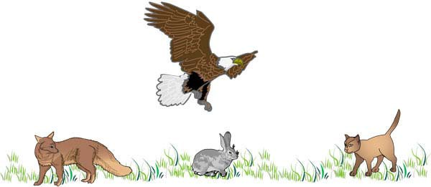
Predator/prey
In this relationship, the predator kills the prey for food.

The size of the prey population can be affected by the number of predators. The predator population can also be affected by the size of the prey population.

The predator/prey relationship is an important factor in maintaining sustainable numbers of organisms as shown in the graph below.

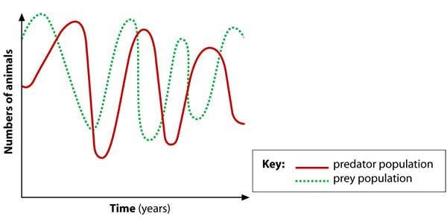

Symbiosis

Some relationships involve two different kinds of organisms living together in close association. These partner-forming relationships include mutualism, commensalism and parasitism.

Mutualism
Both organisms benefit from the relationship, which may be necessary for the survival of both.

Examples:
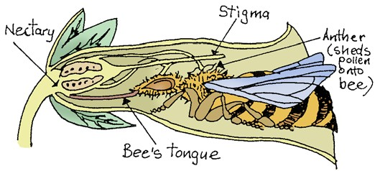
- Lichen, which is a partnership between photosynthetic algae and body-forming fungus.

- Fruit-eating birds and seed dispersal: the undigested seeds are deposited in the bird droppings.
- The flower’s nectar is essential food for the bee. The bee performs the essential service of pollination for the flower.

Commensalism
One organism benefits from the relationship and the other is unaffected.
Example:
- Orchids, ferns, mosses and lichens may grow on the side of a tree to gain light. Such plants are known as epiphytes. They receive the benefit of greater access to sunlight while the larger tree is unaffected.

Parasitism
A relationship where one organism (parasite) benefits and the other is harmed (host). The parasite lives on or in the host. Fleas, ticks and mosquitoes are parasites.
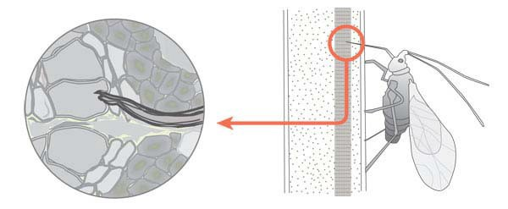
Example:
- Aphids are parasitic insects that obtain nutrients from plant sap.

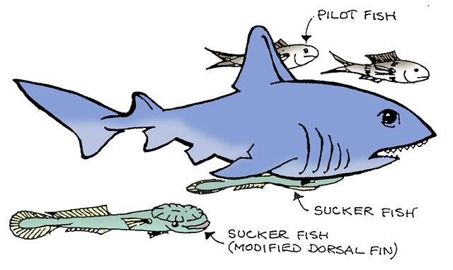
Other partner-forming relationships

Collaboration

Both organisms increase their chance of survival, but the presence of one is not essential for the survival of the other. The remora (sucker fish) travels with the shark eating left over food and any parasites found the shark.

Disease
Disease, is any condition that affects an organism’s normal activity and processes. Organisms that cause disease are called pathogens. For example, fungi, bacteria, viruses and parasites.
Jarrah dieback is a disease caused by fungi.

PRACTICE QUESTIONS:
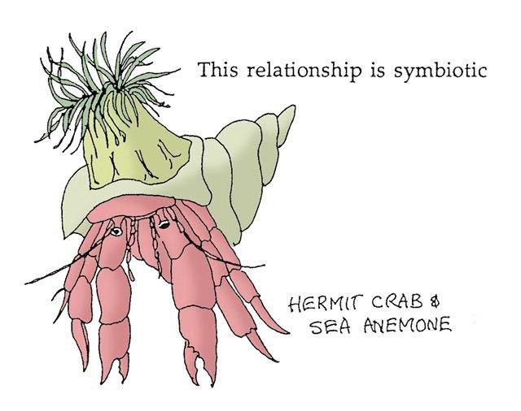
1. What benefit does the crab gain from this relationship?

2. What benefit does the anemone gain from this relationship?

3. Consider cattle and egrets. Decide whether the relationship between these organisms is an example of mutualism, commensalism or parasitism. Explain your answer.

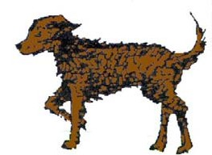
This dog has fleas

4. What type of relationship is displayed here?

5. Which organism benefits?

6. Complete the table.

Relationship | Description | Example
mutualism
 | one benefits, other unaffected
 |  | mosquitoes

7. What happens to predator numbers as the number of prey animals increases?

8. What happens to predator numbers as the number of prey animals decreases?

9. Can herbivores be predators? Explain your answer.

Source Q10 - 13: WATP Unit 1 Biology 2018
10. The Australian Green (weaver) Ant (Oecophylla smaragdina) is an aggressive and territorial species found in northern Australia. However, this ant has been filmed defending caterpillars while they feed off their sugary secretions. This type of symbiosis is known as

- mutualism.
- parasitism.
- commensalism.
- opportunistic feeding.

The Honey possum (Tarsipes rostratus) is a tiny marsupial that inhabits the Banksia woodlands of southwest Western Australia. The Honey possum is nocturnal and feeds on the nectar and pollen from several species of Banksia and Grevillea, along with some low growing Eucalypts. They are able to travel up to 500 metres during a single evening. Honey possums move quickly between plants during feeding sessions to reduce time spent on the ground.

11. Explain the ecological benefits of the Honey possum’s feeding habits.

12. Describe the relationship that exists between the Honey possum and the floral species from which they feed.

Practice Extended Response (10 marks)
13. There are between 2000 and 3000 native species of bees in Australia. Native bees are important, they are involved in the pollination of crops and native plants.
Pollination is one example of an inter-relationship that occurs between different species in ecosystems. Explain five (5) other inter-relationships that you have studied in the course. Identify if there is a benefit or a detriment to each of the species involved. Support your description with a clear example of each type of inter-relationship.

Predator/prey model activity

To complete this activity, you will need the predator/prey equipment:

- 100 red beads
These materials are provided as part of your SIDE Science Kit.
- 100 green beads
- 2 empty boxes.

In this model, green beads represent the predator and red beads represent the prey.

Place 30 red beads and 30 green beads in one of the boxes. This box of beads represents the first generation of predators and prey. This is your pool box.

Shake the box and, without looking, remove two beads. Then use the following assumptions to decide what happens to the beads.

Assumption 1: two red beads = prey survives and mates to produce an offspring.
- Place both the original beads in the second box and add one red bead from the pool.

Assumption 2: two green beads = predator misses prey and the prey survives.
- Place both predators back into the pool box (first box).

Assumption 3: a red and a green bead = predator hit so the prey is eaten.
- Place a green bead in second box and add one green bead from the pool box. Place the red bead back into the pool box.

Repeat the procedure for the next pair until the box is empty.

The second box represents the second generation of predators and prey. Count the number of predators and prey and record the results in the table.

Repeat for 10 generations and record population numbers in second box the table below.

Generation | 1 | 2 | 3 | 4 | 5 | 6 | 7 | 8 | 9 | 10
Prey (red) | 30
Predator (green) | 30

Plot your result on the graph paper below.

Questions:

1. Does your graph reflect the expected predator/prey relationship?

2. Does the model reflect a real predator/prey relationship?

